## STEP1: GOTO ZOHO.COM



## STEP 2: LOGIN TO THE ZOHO.COM



## STEP 3: SELECT ONE APPLICATION



## STEP 4: ENTER APPLICATION NAME

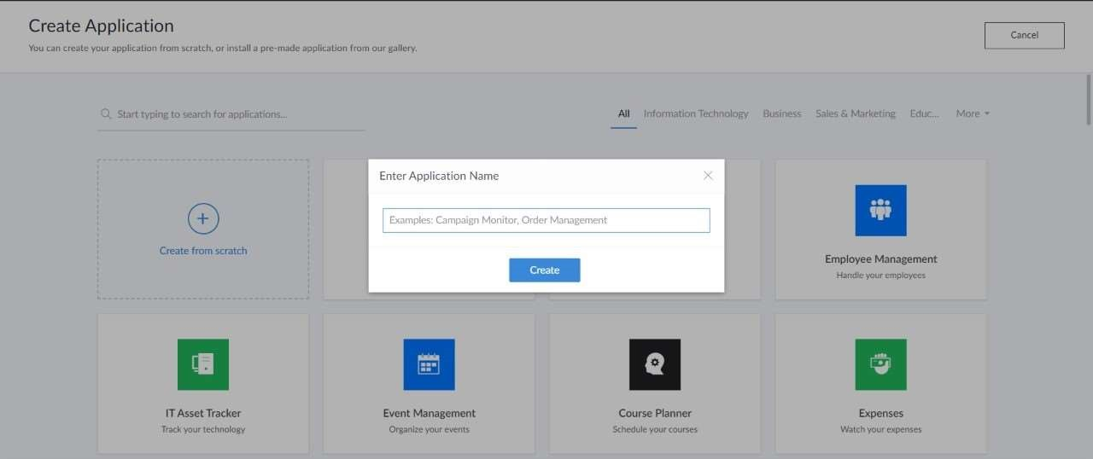

## STEP 5: CREATED NEW APPLICATION

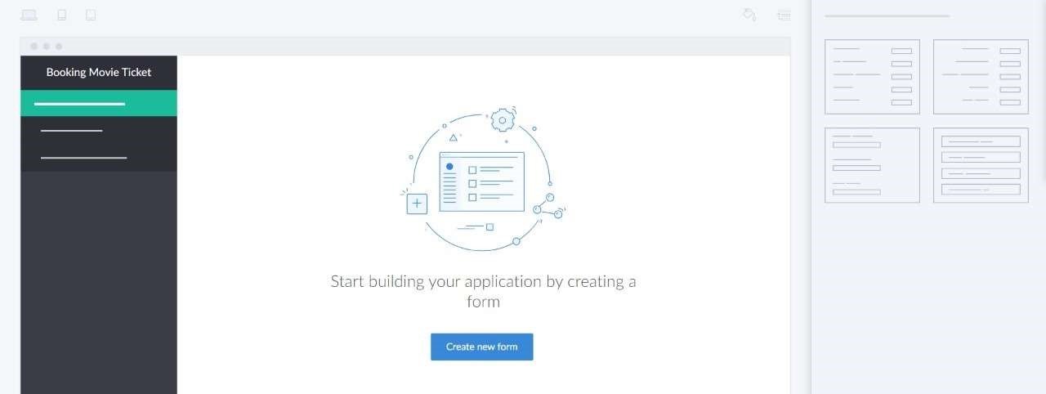

## STEP 6: SELECT ONE FORM

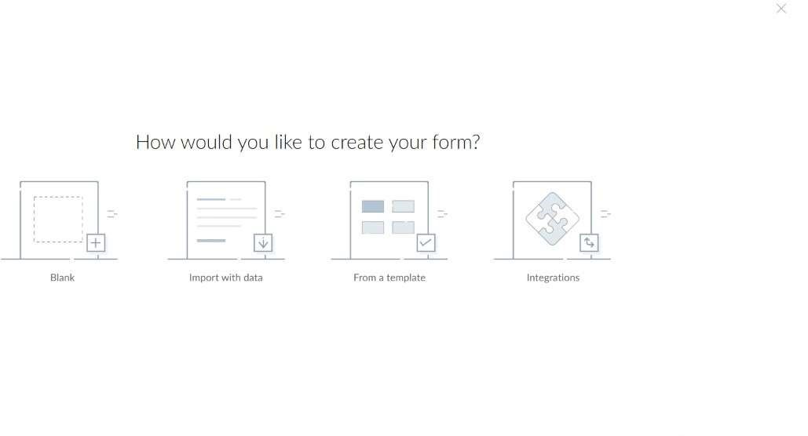

STEP 7: THE SOFTWARE HASE BEEN CREATED.

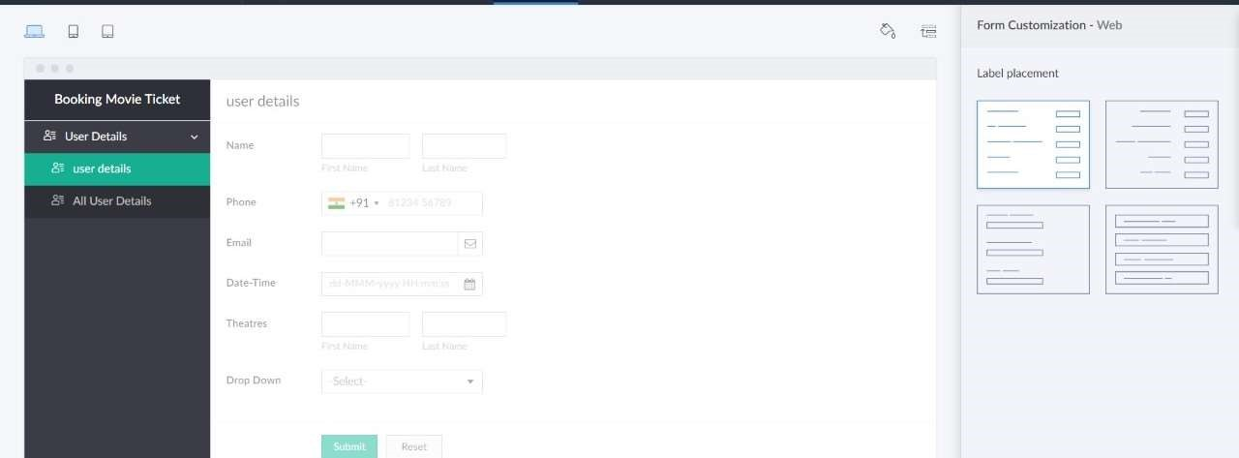

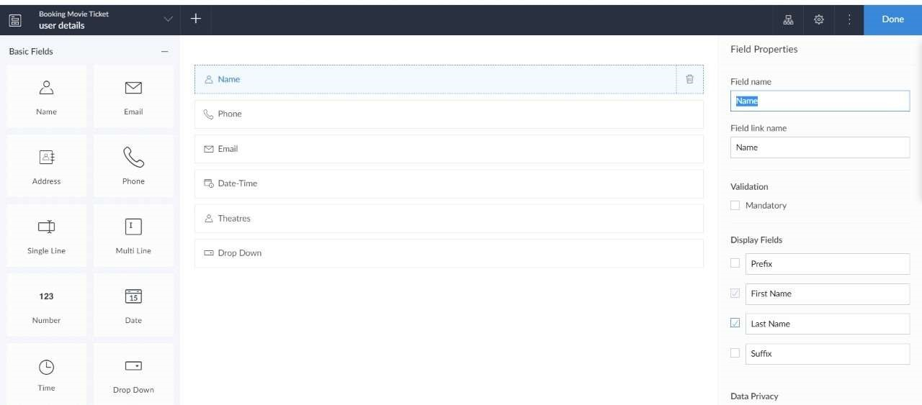

OUTPUT:



